DATE: 30 JULY

git clone <repo>

cd b18projectrepo
mkdir madhukiran
cd madhukiran
touch madhucode
----My name is Madhu ...

git status
git add .
git commit -m "Madhucode"
git log
git push ---> directory push

------------------------

====================================================
PENIDNG TASK :-

ADARSH:

git clone https://github.com/devopstraininghub/b18projectrepo.git
ll --> b18projectrep o

We will prepare the notes ( naku output rala)

cd b18projectrepo
touch Adarsh
git status
git add .
git status
git commit -m "Adarsh commit"
git push

error : permission to b18projectrepo repo denied to adars

-------
form :
https://forms.gle/CTHLaCcWAKp1SUx68

-----
git clone https://github.com/devopstraininghub/b18projectrepo.git
ll --> b18projectrepo

cd b18projectrepo
touch rajanikanth
git status
git add .
git status
git commit -m "rajanikanth commit"
git push
HERE IS COMING TWO ISSUES when type git push some we are below issue :-
After we will run below command 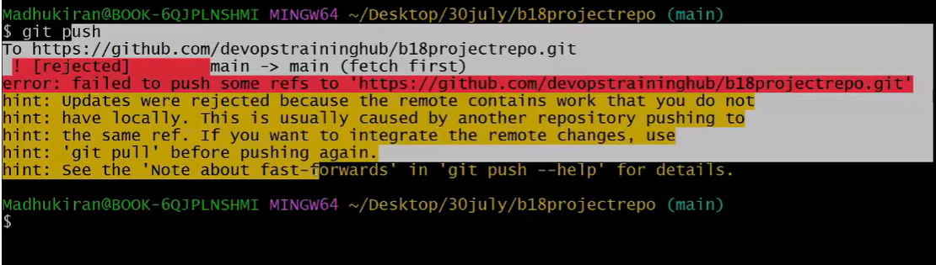
git pull --rebase ( it is used rarely case )
git push

BELOW DIGRAM SEANRIO :-

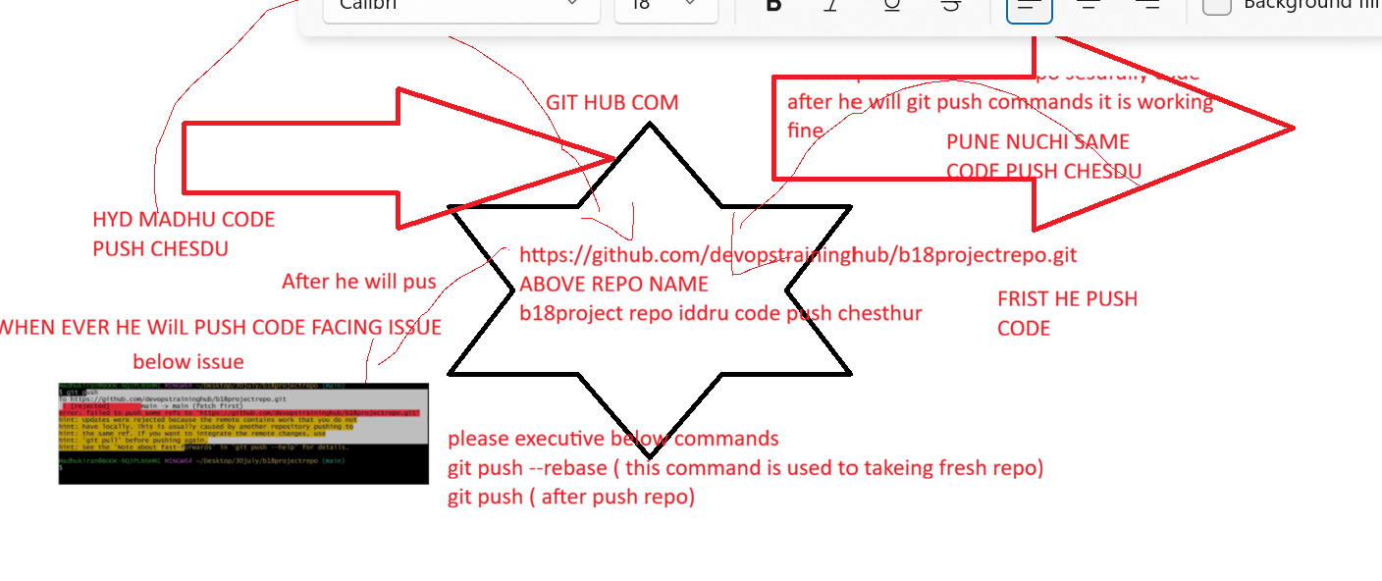

GIT BRANCH FLOW :-
COPY OF DATA

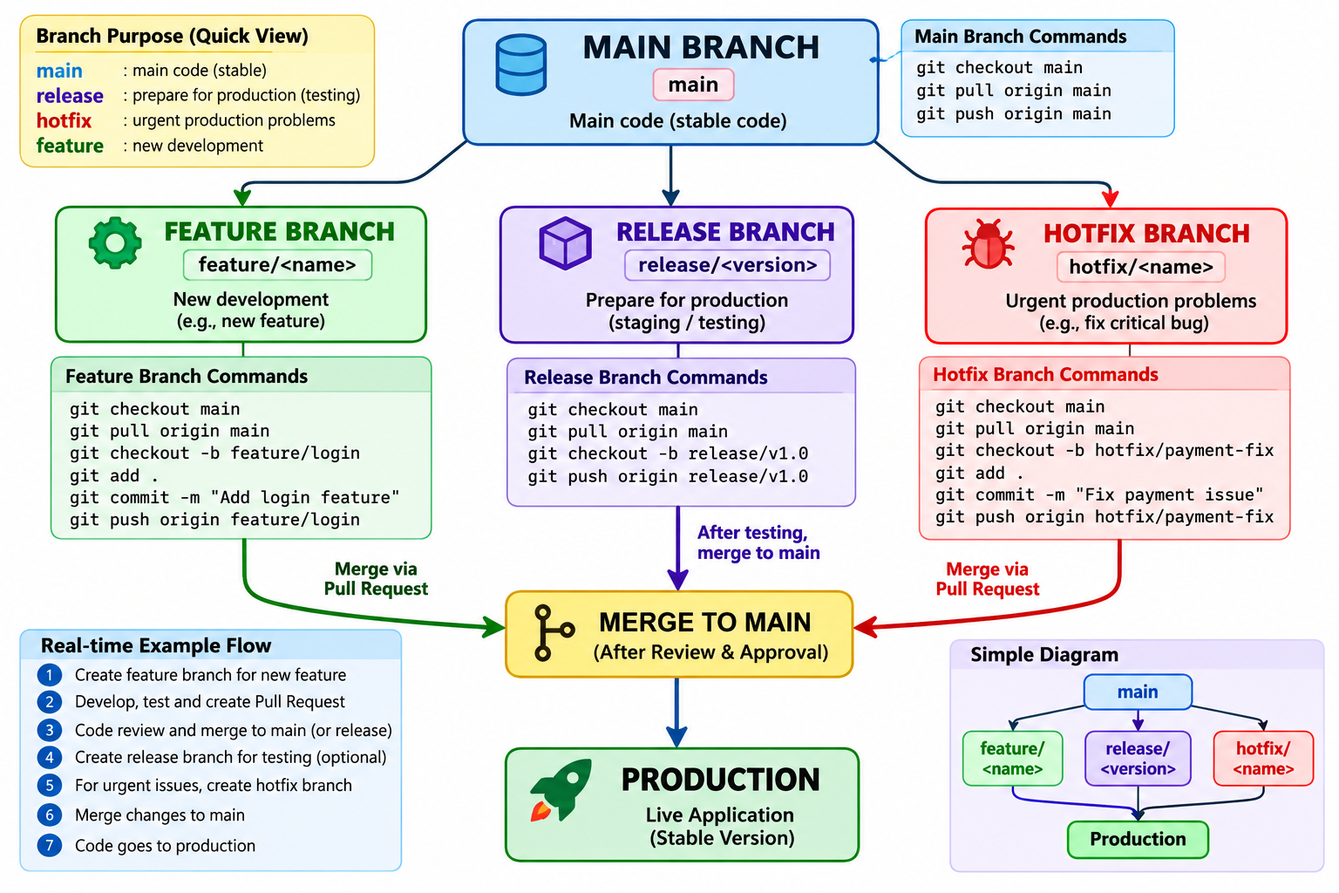
EXAMPLE OPEN SOURCE PROJECT:-
jenkinsci/jenkins: Jenkins automation server (Jenki code market avalibale)
kubernetes/kubernetes: Production-Grade Container Scheduling and Management
kubernetes/kubernetes: Production-Grade Container Scheduling and Management

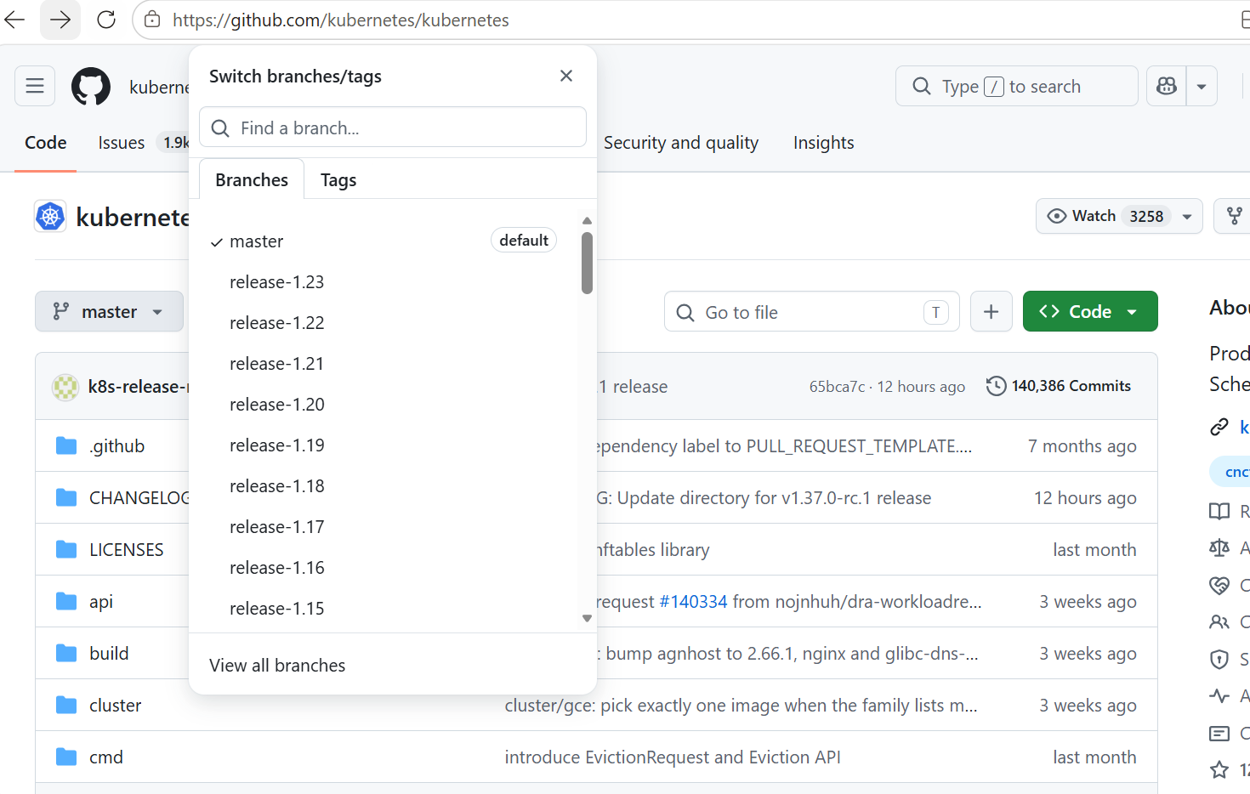

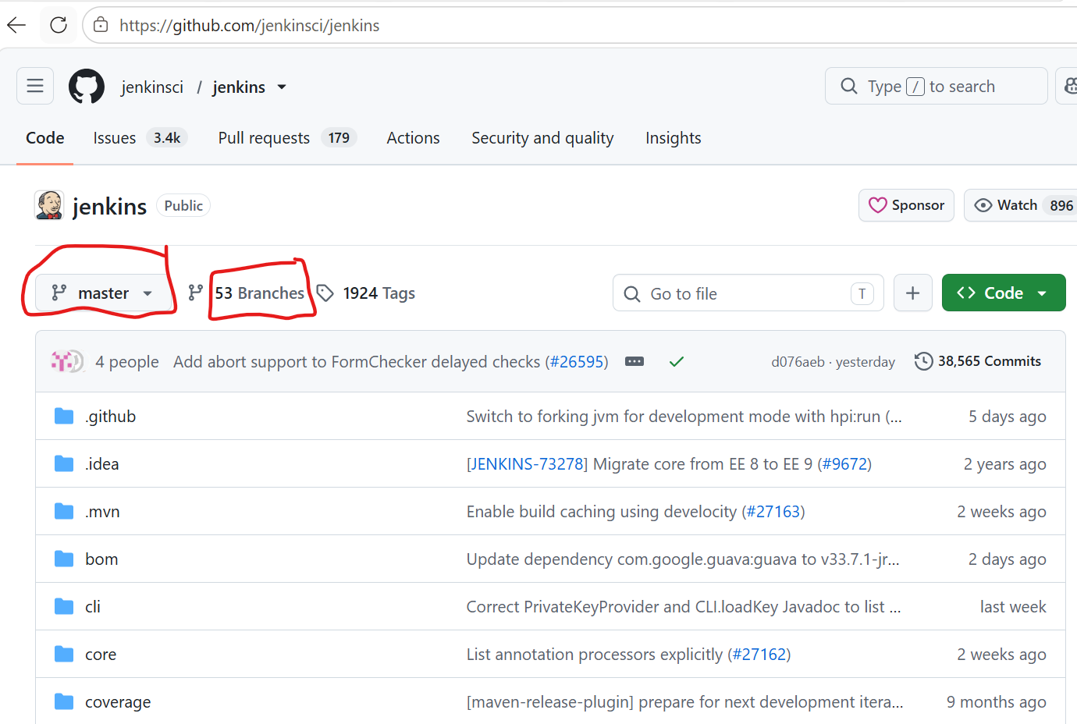
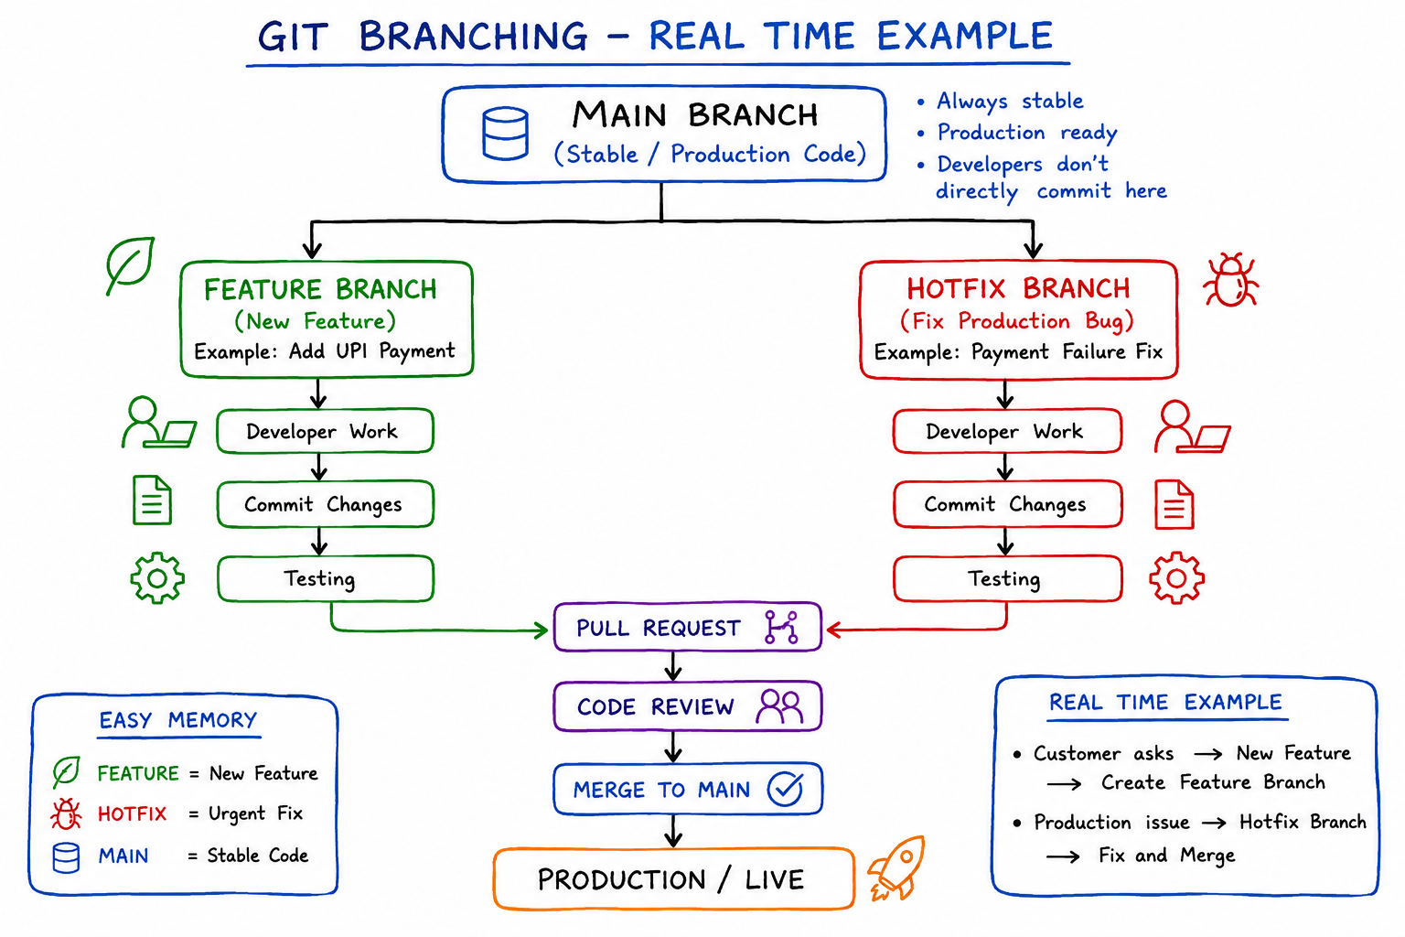

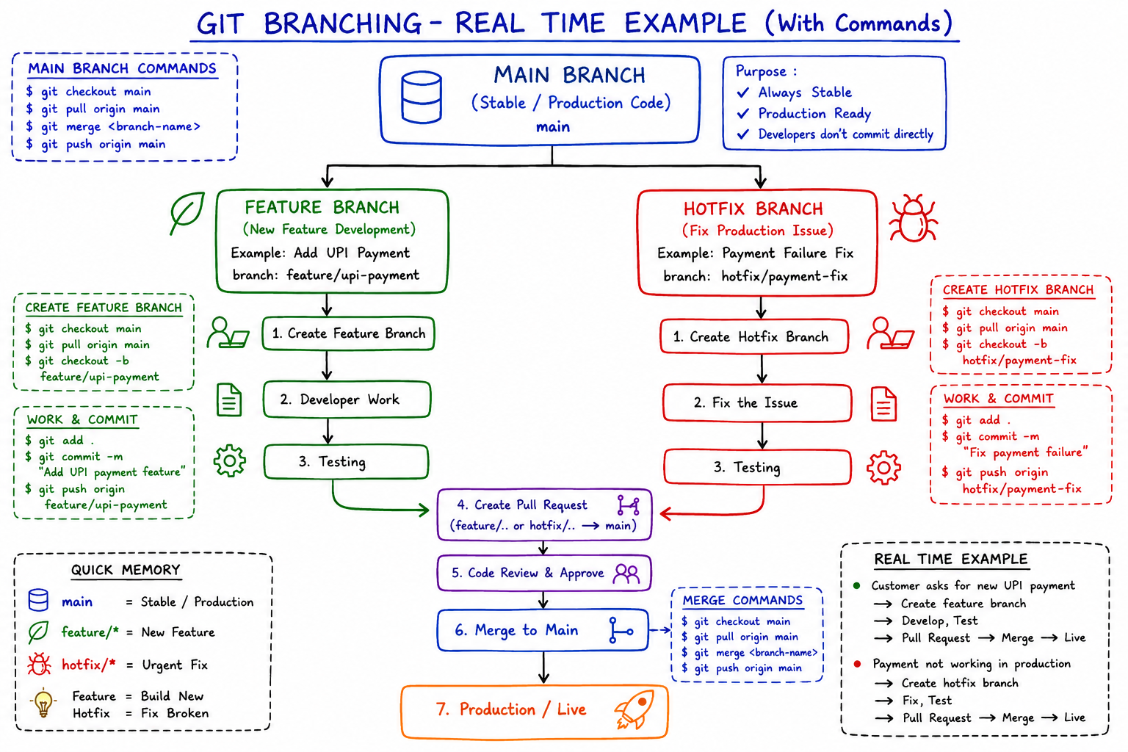
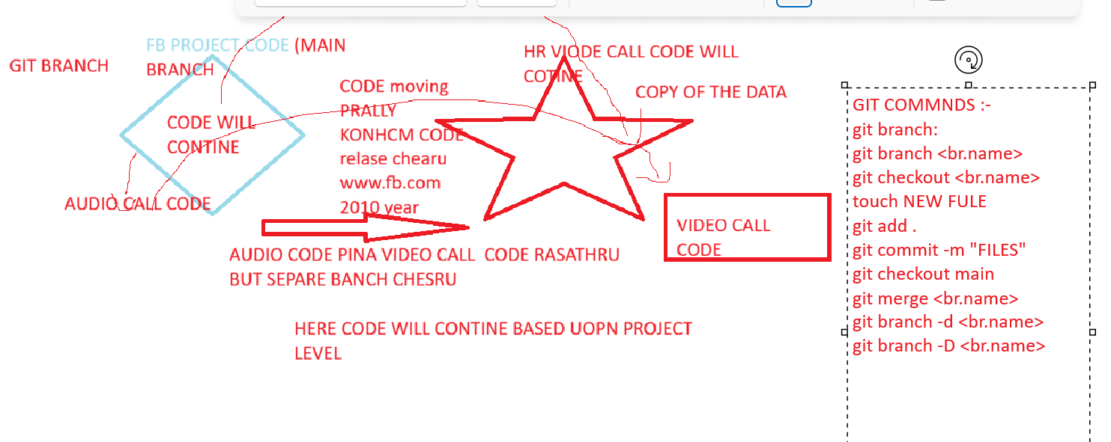
SETP 1:- git branch
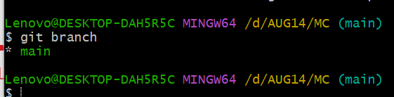
SETP 2:- ls –lrth
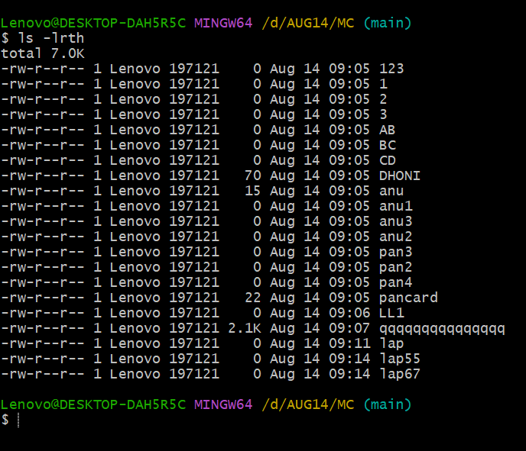

SETP 3:- below output to create new branch and switch to AUDIO_BR
Git branch AUDIO_BR (create new branch)
Git branch ( to see how many branches)
Git checkout AUDIO_BR ( moving audio_BR)
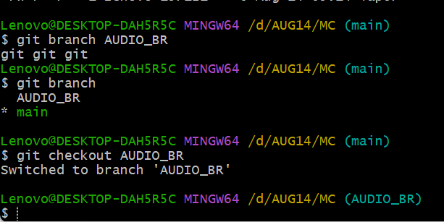

SETP 4:- to see below output same files are there audio_br also what ever files are the main branch vs same files are there audio_br branch

MAIN BRANCH output :-

MAIN BRANCH EVARU TOUCH CHEYRU , INKO BRNACH CREATE CHESTHRU AA CODE NI
FEATURE BRANCH CREATE CHESTHRU
FEATURE BRANCH UNNA CODE TEST CHESINA AFTER MAIN BRNACH MERAGE CHESTHRU
SEPARTEE INKO BRNACH FEATURE BRANCH CREATURE CHESTHRU
MAIN BRANCH :- main code
Release branch :- To release the code public level
HOT FIX BRANCH :- branch is for urgent production problems.
FEATURE BRANCH :- feature branch is for new development
Absolutely. Here is a real-time Git branching example you can use for training.

Git Branching – Real-Time Project Example
Imagine an e-commerce application called ShoppingApp.

1. Main Branch
main contains the stable production code.
MAIN
|
v
-----------------------
Production Version
-----------------------
Example:
git checkout main
git pull origin main
Rule: Developers normally should not directly make changes to main.

2. Feature Branch
Suppose the business asks:
"Add a new online payment option."
Developer creates a feature branch:
git checkout main
git pull origin main

git checkout -b feature/payment
Development happens on:
main
|
+---- feature/payment
|
+-- payment code
+-- testing
+-- bug fixing
Then:
git add .
git commit -m "Added payment feature"

git push origin feature/payment
Create a Pull Request:
feature/payment
|
| Pull Request
v
main
After code review and testing:
git checkout main
git pull origin main
git merge feature/payment
git push origin main

3. Hotfix Branch
Now imagine the application is already in production, and suddenly customers cannot make payments.
This is a critical production issue.
Create a hotfix branch from main:
git checkout main
git pull origin main

git checkout -b hotfix/payment-error
Fix the production problem:
git add .
git commit -m "Fixed production payment error"

git push origin hotfix/payment-error
Then create a Pull Request:
main
|
|
hotfix/payment-error
|
Production Fix
|
v
main
After approval:
git checkout main
git pull origin main
git merge hotfix/payment-error
git push origin main

Complete Real-Time Workflow
MAIN
|
+------------+------------+
| |
v v
FEATURE BRANCH HOTFIX BRANCH
feature/payment hotfix/login-error
| |
| Development | Production bug
| |
v v
Testing Fix
| |
+------------+------------+
|
v
Pull Request
|
v
MAIN
|
v
PRODUCTION

Simple Difference
Branch | Purpose | Example
main | Production/stable code | Live application
feature/* | New functionality | feature/payment
hotfix/* | Urgent production fix | hotfix/payment-error

Real Company Scenario
Customer Request
↓
feature/payment
↓
Developer Coding
↓
Code Review
↓
Testing
↓
Pull Request
↓
main
↓
Production
If production has an urgent problem:
Production Issue
↓
main
↓
hotfix/payment-error
↓
Fix + Test
↓
Pull Request
↓
main
↓
Production Fixed
Important: A feature branch is for new development, while a hotfix branch is for urgent production problems.

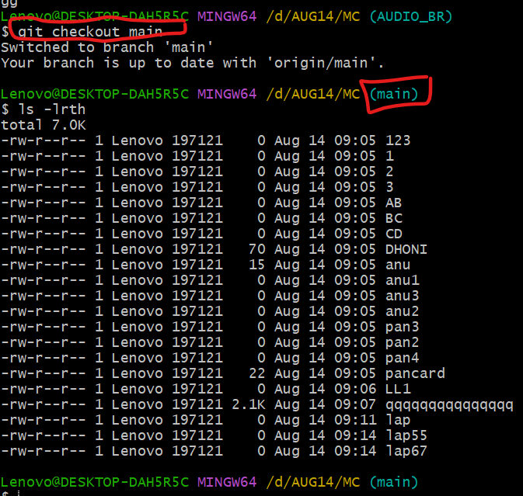

AUDIO_BR OUTPUT
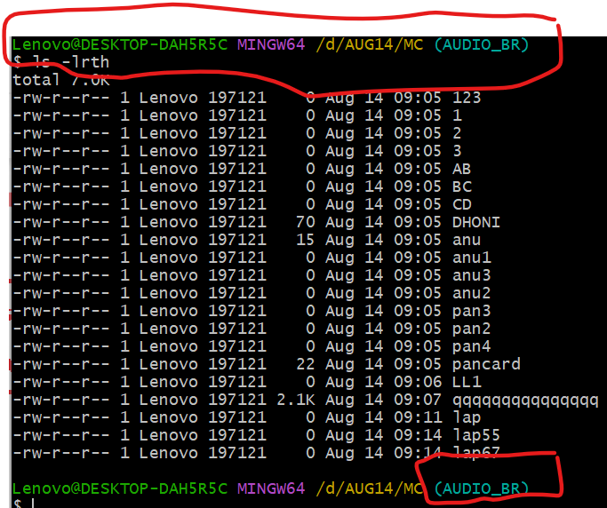

=====================================================================
LA B :-

STEP 1:-
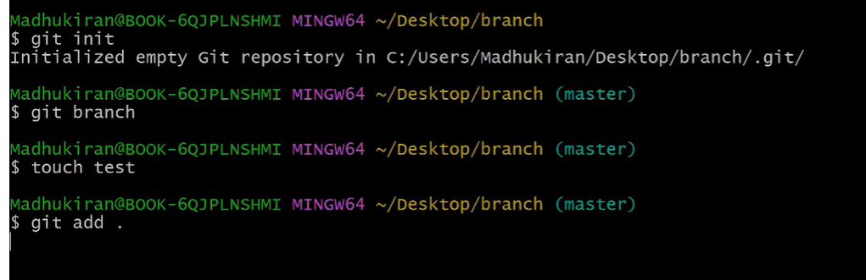
STEP 2:-
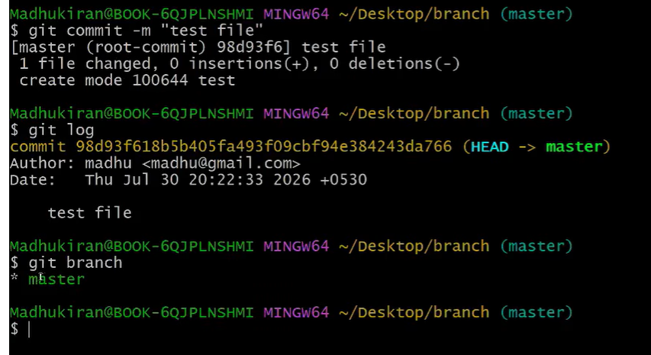
SETP 3:-
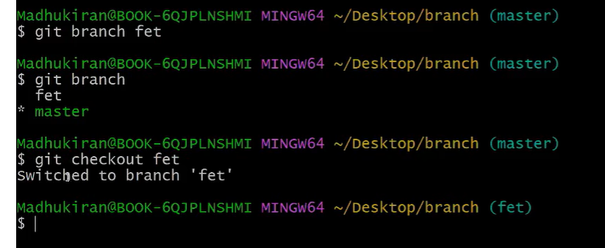
STEP 4:-
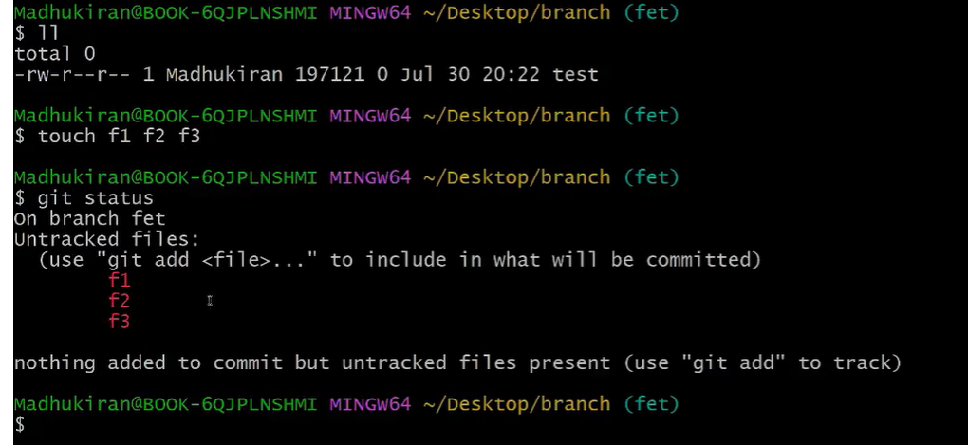

SETP 5:-
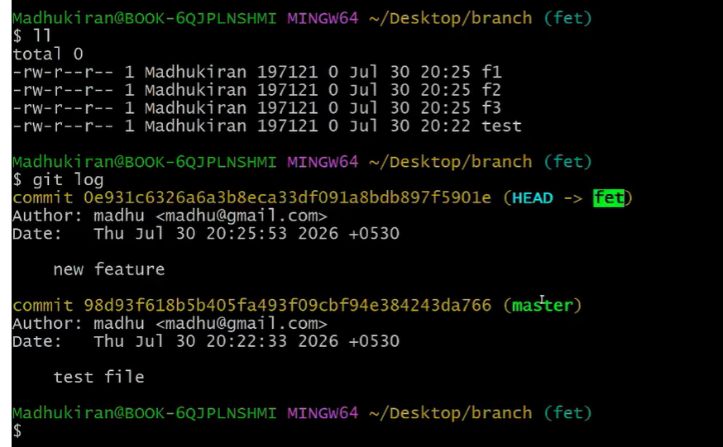
SETP 6:-
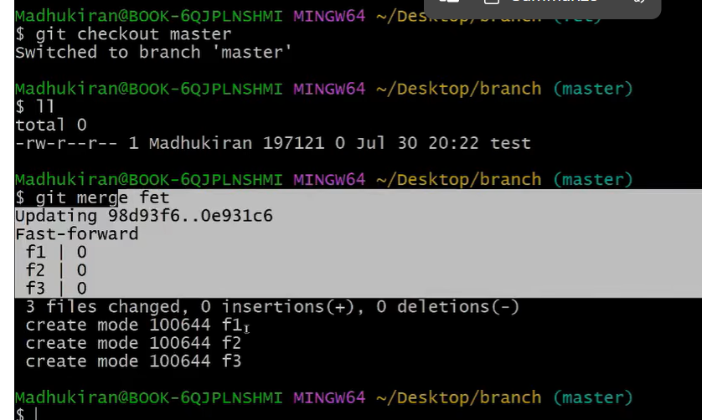
SETP 7:-

